**SMART HOME & APPLIANCES**

***Prepared By:***

***Shailee Mehta***

***(150120116036)***

**Chapter-1**

**Introduction**

* 1. **Organization Profile**
     1. **Introduction**
* Prismetric is a venture of two technocrats having their individual core expertise in mobile solutions, web solutions, CRM solutions and Business Intelligence solutions. Their synergy worked exceptionally well and within a short span of time, the company became a leading provider for full-range technical solutions.
* Our Aim is to invest our knowledge, resource and technology for fulfilling their aim glitch-free so as to aid them in the development. We believe our solutions will support the organizations to meet any impeding business scenarios with confidence.
* Our mission is t*o technically enable the startups and mechanize large scale enterprises through innovative solutions.*
* Our main focus area are:

**-**  No Compromise on Quality

* Proven Quality Check and Process
* Technology
  + 1. **Logo, Company Address, Guide Details**

**Logo**

* **Company Address:**

SF/215 IT Tower 1,  
Infocity,

Gandhinagar,  
Gujarat 382007

* **Guide Details:**

Name: Mr. Ashish Parmar

Mobile No: 7043308535

Email ID:-[aparmar@prismetric.com](mailto:nimitajoshi@gmail.com)

* + 1. **Product and Technology**

The current product is basically based on IOT working in android.

The technology used is android. Since inception, we have been playing an integral role as a comprehensive Android application development company, rendering customized solutions that comply with the client’s requirements. Our key to success is a dedicated team of Android developers who have vast knowledge and experience in building cutting-edge, [innovative mobile applications design](https://www.prismetric.com/mobile-app-design/). We develop a deep understanding of client project demands and deliver the best app solution on time and within budget. Harnessing the potential of our talent pool, we have emerged as the first choice in India and overseas.

* + 1. **Clients of Company**

The clients of prismetric have been very happy till now. Here are few clients review-

*All I have to say is that Prismetric is a perfect company to partner with. We came with up a product that was our dream. They delivered a product that is already live and we have users using it. They have great support, great managers and ability to take your plan and develop a real product. We will keep using them as we continue building the product.*

#### **-TAUREAN GORDO,** CEO Pairchute Corp

*It was definitely a good experience with them and they helped to short the learning curve for our company. We hired Prismetric to develop iPad application. Prismetric team is very professional and they have always exceeded my expectations. I will continue to hire them for all my all mobile app development work.*

#### **-CURT HAYES,** President Audio Design Inc

* 1. **Project Detail**
     1. **Project Profile**
* There are various Smart Home Systems available in the market and lately, people are very attracted with it. Google Home is one of the example.
* Therefore, we decided to develop an android application which would help people by saving expense and by increasing the range of connectivity.
* **Project Definition**
* Arduino based “Home Automation” using Bluetooth helps a user control any electronic device.
* The android app will sends command to Arduino through wireless communication i.e., Bluetooth.
* By using Arduino and wireless communication i.e., Bluetooth any AC/DC devices can be controlled.
  1. **Purpose**
* Most of the people lock their houses and either forget to take the keys from office or drop somewhere but with the help of Smart home; ‘No Keys Required.’
* This application warns you if there is gas leakage. .
* You can watch your home while you’re away.
  1. **Scope**
* This project work is complete on its own in remotely and automatically switching on or off of an electrical appliance not limited to household appliances and sends a feedback message indicating the new present state of the appliance.. The features described here meet the needs of all the users.

**1.5.Objective**

* Low cost, reliable.
* Home automation system that can be used to control and home appliance remotely.
* Hardware simplicity can be achieved using a micro-controller..

**1.6.Tools & Technology**

* As we are developing an android application, we will be using Android technology along with Java and Embedded C.
* ANDROID
* Android is an open source & license free mobile operating system developed by Google, based on the Linux kernel and designed primarily for touchscreen mobile devices such as smartphones and tablets..
* Java
* Android applications are written in: Java.
* Java is a general-purpose computer programming language that is concurrent, class-based and object-oriented.
  1. **Literature Review**

As per our survey, there exist many systems that can control home appliances using android based phones/tablets. Each system has its unique features. Currently certain companies are officially registered and are working to provide better home automation system features. Following models describes the work being performed by others. Our designed system has application layer prototype. The application is able to synthesize the speech data with the help of Google Voice Reorganization. The synthesized data are analyzed and further processing is carried out. In layman words, our design system provides features of controlling the home appliances using voice commands.

The use of socket programming is performed to connect the android application with the raspberry pi. This further adds security to our system. The data are received only by the server at the specified port and data are further analyzed. Our project is different in a sense it has its own software level application to control the home Appliances.

**Chapter-2**

**About The System**

**2.1. Software Requirement Specification (SRS)**

**2.1.1. Introduction**

* Day by day due to escalation of science and technology, Smart Home is becoming very much popular these days.
* People often forget to switch of appliances like fans, lights and this Smart Home will sort out this issue.
* As the technology is growing so rapidly, the new technology must be adopted.

* ***Purpose***
* This Software Requirements Specification (SRS) provides a description of all the functions, specifications, external behaviors, design constraints, requirements (function and non-functional) and other factors necessary to provide a complete and comprehensive description of the proposed Smart Home and Appliances.
* The Software Requirements Specification (SRS) captures the complete software requirements for the system, or a portion of the system.
* ***Scope***
* The Software Requirements Specification captures all the requirements in a single document. The Smart Home and Appliances is to be developed provides the users with many facilities.
* The Smart Home and Appliances is supposed to have the following features:
* The system provides Gas leakage detection.
* The system provides logon facility to the users.
* ***Definitions, Acronyms and Abbreviations***
* Android – A popular operating system developed by Google
* JAVA – Java is a general-purpose Object Oriented Programming language developed by James Gosling at Sun Microsystems.
* Arduino -- Arduino is an open source computer hardware and software company, project, and user community that designs and manufactures [single-board microcontrollers](https://en.wikipedia.org/wiki/Single-board_microcontroller) and [microcontroller](https://en.wikipedia.org/wiki/Microcontroller) kits for building digital devices and interactive objects that can sense and control objects in the physical and digital world.
* IDE -- Integrated Development Environment
* ADLs -- Activities of Daily Livinng

* ***References***
* The *SRS document* uses the following documents as references: .
* The Smart Lock System: To avoid users from forgetting keys at work place or elsewhere.
* ***Overview***
* The SRS will provide a detailed description of the Smart Home and Appliances. This document will provide the outline of the requirements, overview of the characteristics and constraints of the system.

**2.2 Project Planning**

**2.2.1 Project Development Approach**

* We have used the Incremental Model approach for the Project Development.

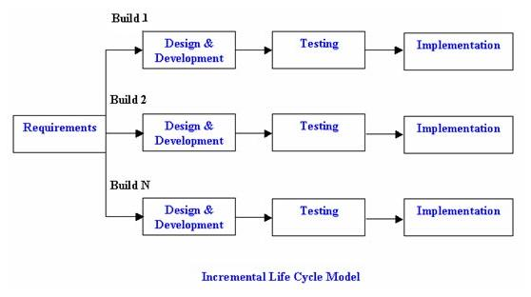

**Fig.2.1 Incremental Model**

* In Incremental model the Project requirements are divided into multiple modules and each module is developed separately. Finally developed modules are integrated with other modules.
* Incremental process goes until all the requirements fulfilled and whole system gets developed.
* Incremental Model helps to deliver the sequence of releases in incremental basis which speeds up the progress of development of each functionality.

**Chapter-3**

**Analysis of the System**

**3.1. E-R Diagram**

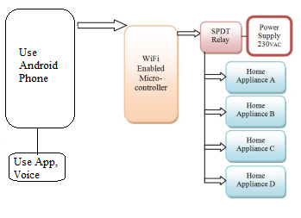

**Figure 3.1 E-R Diagram**

**3.2. Data Flow Diagram**

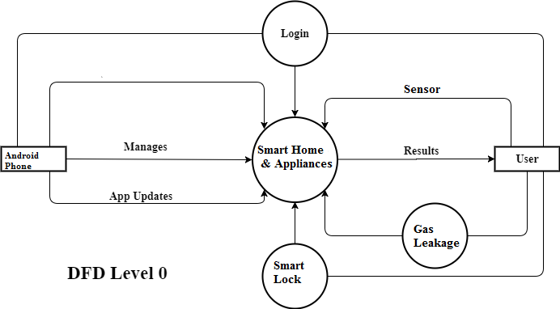

**Figure 3.2.2 DFD Level 0**

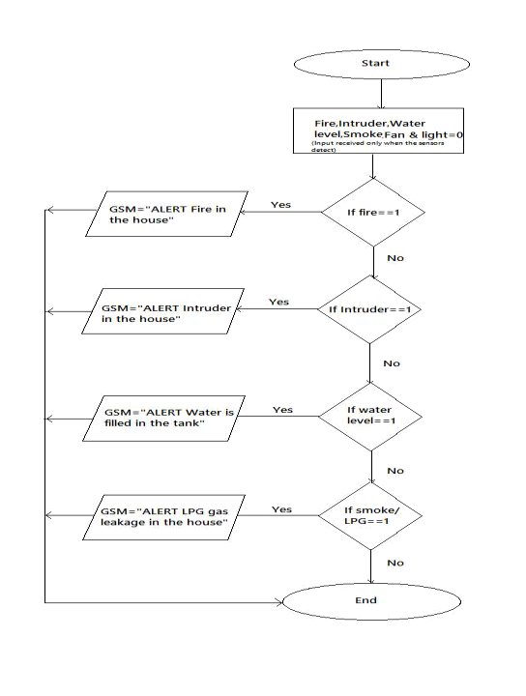

**Figure 3.2.2 DFD Level 1**

**3.3. Use Case Diagram**

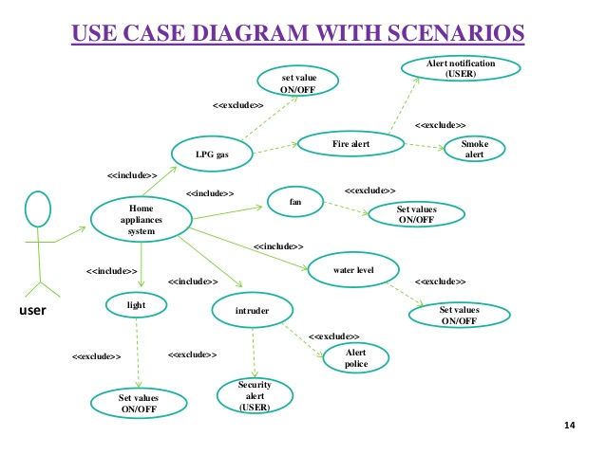

**Figure 3.3 Use Case Diagram**

**3.4. Sequence Diagram**

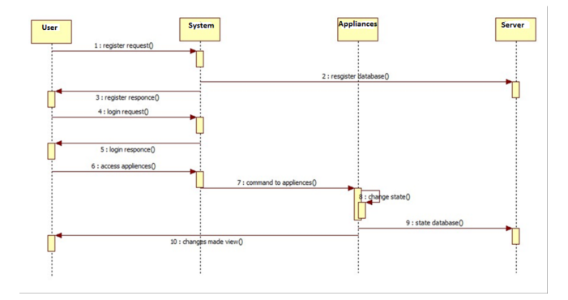

**Figure 3.4 Sequence Diagram**

**3.5. Activity Diagram**

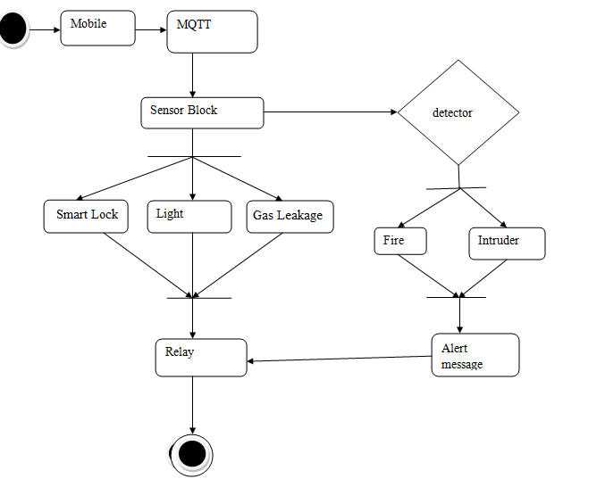

**Figure 3.5 Activity Diagram**

**3.6. Class Diagram**

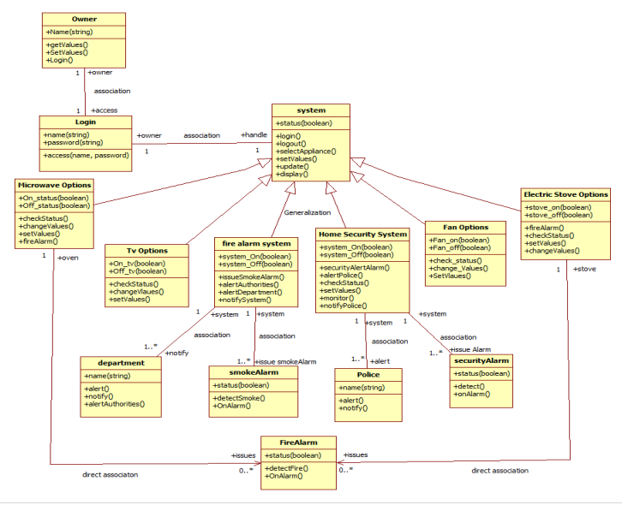

**Figure 3.6 Class Diagram**

**Chapter-4**

**Design**

**4.1. System Flow Diagram**

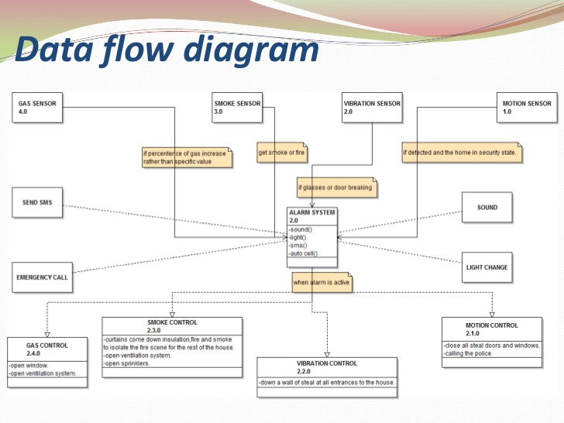

**Figure 4.1 System Flow Diagram**

**4.2. Data Dictionary**

**4.2.1 Table name: Device Registration**

**Description of table: Store The login information and Device Key**

**Device Registration**

|  |  |  |  |  |  |
| --- | --- | --- | --- | --- | --- |
| **Sr. No** | **Column name** | **Data Type** | **Size** | **Constraints** | **Description** |
| 1 | EMAIL | VARCHAR | 60 | PRIMARY KEY | EMAIL OF REGISTERED DEVICE |
| 2 | PASSWORD | VARCHAR | 15 | NOT NULL | PASSWORD OF REGISTERED DEVICE |
| 3 | NAME | VARCHAR | 15 | NOT NULL | NAME OF DEVICE OWNER |

|  |  |  |  |  |  |
| --- | --- | --- | --- | --- | --- |
| 4 | UID1 | VARCHAR | 15 | PRIMARY KEY | UNIQUE IDENTIFICATION KEY OF OF HOME AUTOMATION DEVICE |
| 5 | UID2 | VARCHAR | 15 | PRIMARY KEY | UNIQUE IDENTIFICATION KEY OF GAS LEAKAGE DETECTION DEVICE |
| 6 | UID3 | VARCHAR | 15 | PRIMARY KEY | UNIQUE IDENTIFICATION KEY OF SMART DOOR LOCK DEVICE |

**4.2.2.Name of Table: HOME AUTOMATION DEVICE STATUS**

**Description of table:** It stores the On/Off Status Of Connected Device

**HOME AUTOMATION DEVICE STATUS**

|  |  |  |  |  |  |
| --- | --- | --- | --- | --- | --- |
| **Sr. No** | **Column name** | **Data Type** | **Size** | **Constraints** | **Description** |
| 1 | RELAY1 | SORT INT | 1 | PRIMARY KEY | STATUS OF CONNECTED DEVICE TO RELAY1 |
| 2 | RELAY2 | SORT INT | 1 | PRIMARY KEY | STATUS OF CONNECTED DEVICE TO RELAY2 |
| 3 | RELAY3 | SORT INT | 1 | PRIMARY KEY | STATUS OF CONNECTED DEVICE TO RELAY3 |
| 4 | RELAY4 | SORT INT | 1 | PRIMARY KEY | STATUS OF CONNECTED DEVICE TO RELAY4 |

**4.2.3Name of Table: GAS LEAKAGE DEVICE STATUS**

**Description of table:** It stores the data of Gas Leaking

**GAS LEAKAGE DEVICE STATUS**

|  |  |  |  |  |  |
| --- | --- | --- | --- | --- | --- |
| **Sr. No** | **Column name** | **Data Type** | **Size** | **Constraints** | **Description** |
| 1 | GAS LEAKAGE | BOOL | 1 | PRIMARY KEY | STATUS OF GAS LEAKING |

**4.2.4.Name of Table: SMART DOOR PERMISSION**

**Description of table:** It stores the Email of the users that can access the door.

**SMART DOOR PERMISSION**

|  |  |  |  |  |  |
| --- | --- | --- | --- | --- | --- |
| 1 | EMAIL | VARCHAR | 50 | PRIMARY KEY | EMAIL OF THE USERS THAT CAN ACCESS THE DOOR WITH APP |
| 2 | PERMISSION STATUS | BOOL | 1 | NOT NULL | THE PERMISSION LEVEL OF USER |

**4.3. Relationship of Table**

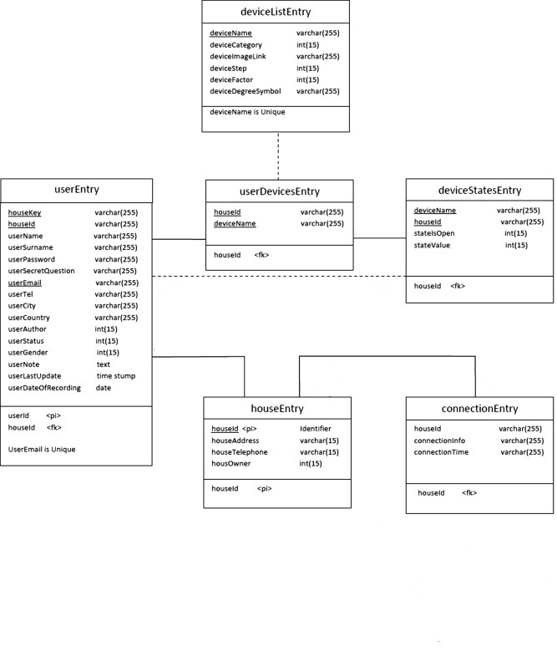

**Figure 4.3 Relationship of Table**

**4.4. User Interface**

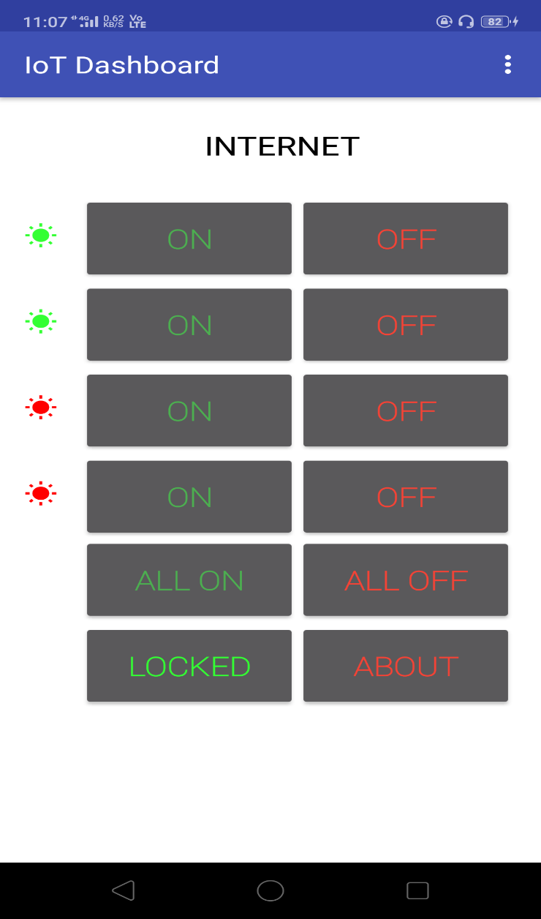

**Fig. 4.4.1 User Interface**

**Chapter-5**

**Implementation**

**5.1. Implementation Environment**

This describes the technological and physical environment in which the product is to be installed. It includes automated, mechanical, organizational, and other devices, along with the nonhuman adjacent systems.

**5.2. Security Feature**

To make sure no one else but the authenticated user is able to unlock the door or uses the application, the system needs to have good security both between the server and phone/device and between the device and lock, if a wireless solution is used here. For the Internet traffic between the server and phone/device HTTPS could be used instead of HTTP traffic. HTTPS is the HTTP protocol layered on top of the TLS (Transport Layer Security) [56] protocol to achieve secure communication over the Internet. HTTPS provides authentication of the web server that the user is communicating with and thus prevents man-in-the-middle attacks. It also supports bidirectional encryption of data which protects against eavesdropping and tampering with the data by a third party. In practice this means that when the user uses the application to unlock a door, the client only communicates with the correct server, no information (name, password) is sent in plain text and no one else can impersonate that user.

**5.3. Coding Standard(s)**

* **Coding Standards for Components:**It is recommended to write components name by its purpose. This approach improves the readability and maintainability of code.
* **Coding Standards for Classes:**Usually class name should be noun starting with uppercase letter. If it contains multiple word than every inner word should start with uppercase. Eg: String, StringBuffer, Dog
* **Coding Standards for Interface:** Usually interface name should be adjective starting with uppercase letter. If it contains multiple word than every inner word should start with uppercase. Eg: Runnable, Serializable, Comparable
* **Coding Standards for Methods:**Usually method name should either be verb or verb noun combination starting with lower letter. If it contains multiple word than every inner word should start with uppercase. Eg: print(), sleep(), setDate)
* **Coding Standards for Variables:** Usually variable name should be noun starting with lowercase letter. If it contains multiple word than every inner word should start with uppercase. Eg: name, age. mobileNumber
* **Coding Standards for Constants:**Usually constant name should be noun. It should contain only uppercase If it contains multiple word than words are separated with ( _ ) underscore symbol. Usually we declare constants with public static and final modifiers.

**5.4. Data Access Layer**

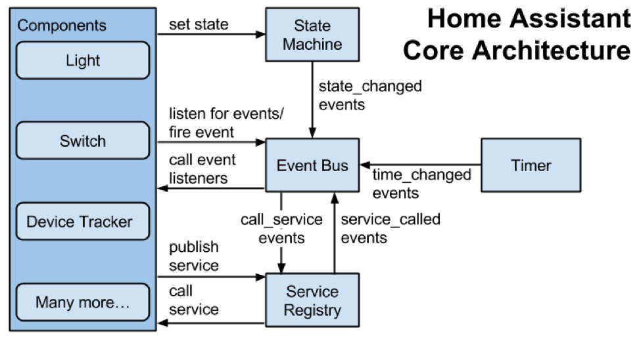

**Fig. 5.4.1. data access layer**

**5.5. Business Logic Layer**

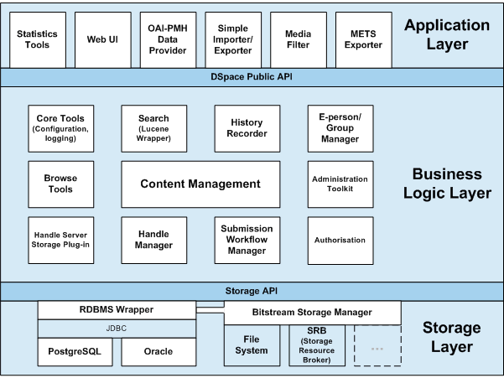

**5.5.1. Business Logic Layer**

**Chapter-6**

**Testing**

**6.1. Testing Plan**

After the completion of the hardware coupling, several tests were done on the design. Some observations and corrections were made which we will see below.

**6.2. Testing Strategy**

In designing the case for the system, utmost concern was given to guarding the system from physical strain and stress during carriage and project presentation. A transparent plastic material was used for the casing as against glass material which 54 may easily break, a paper material which may give in to strain and stress, or even a metallic material which will make the project work quite uneconomical, clumsy and heavy. The casing was made in a manner that permits the whole circuit board to be detached from the system.

**6.3. Testing Methods**

1. **Compatibility Testing**
2. **Upgrade testing**
3. **Real-time data testing**

**6.4. Test Cases**

Test 1- The system would not work when the phone is connected after powering it, even after a reset. This was due to the fact that the signals sent at first by the system to the phone do not die of the line immediately and affects subsequent signals sent even after connecting and resetting the system. This can be prevented by connecting the phone first before powering the system. Much concern was not given to this shortcoming because the system was designed to have a permanently connected phone, making it impossible for this shortcoming to arise.

Test 2- Test 2 actually is a formal step that is so important in our design. In this test each component will be tested individually and feedback reports will be written and calculations will be made, in order to measure the efficiency of each component

**Chapter- 7**

**Application Screenshot**

**7.1. Client side with description**

Firebase Storage provides a simple way to save binary files — most often images, but it could be anything — to Google Cloud Storage directly from the client.

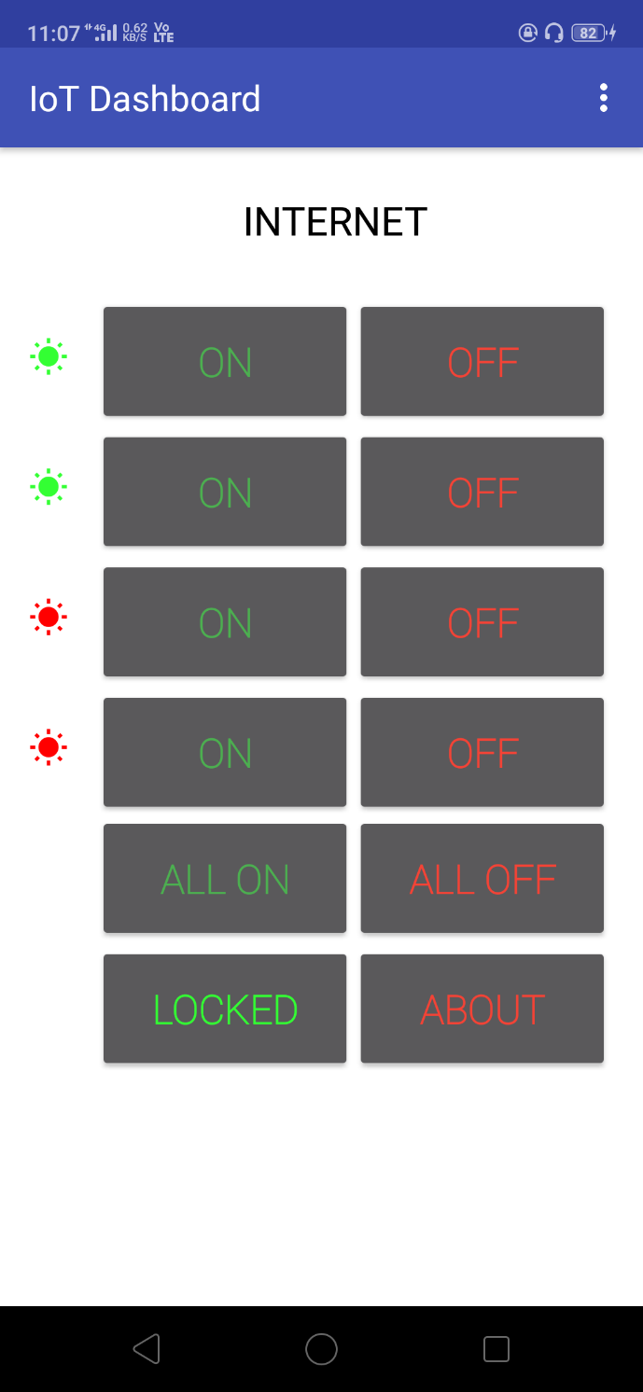

**Fig. 7.1. Client side application screenshot**

**7.2. Server side with description**

Firebase is a Backend-as-a-Service — BaaS — that started as a YC11 startup and grew up into a next-generation app-development platform on Google Cloud Platform.

Firebase frees developers to focus crafting fantastic user experiences. You don’t need to manage servers. You don’t need to write APIs. Firebase is your server, your API and your datastore, all written so generically that you can modify it to suit most needs. Yeah, you’ll occasionally need to use other bits of the Google Cloud for your advanced applications. Firebase can’t be everything to everybody. But it gets pretty close.

Real-time data is the way of the future. Nothing compares to it.

Most databases require you to make HTTP calls to get and sync your data. Most databases give you data only when you ask for it.

When you connect your app to Firebase, you’re not connecting through normal HTTP. You’re connecting through a WebSocket. WebSockets are much, much faster than HTTP. You don’t have to make individual WebSocket calls, because one socket connection is plenty. All of your data syncs automagically through that single WebSocket as fast as your client’s network can carry it.

Firebase sends you new data as soon as it’s updated. When your client saves a change to the data, all connected clients receive the updated data almost instantly

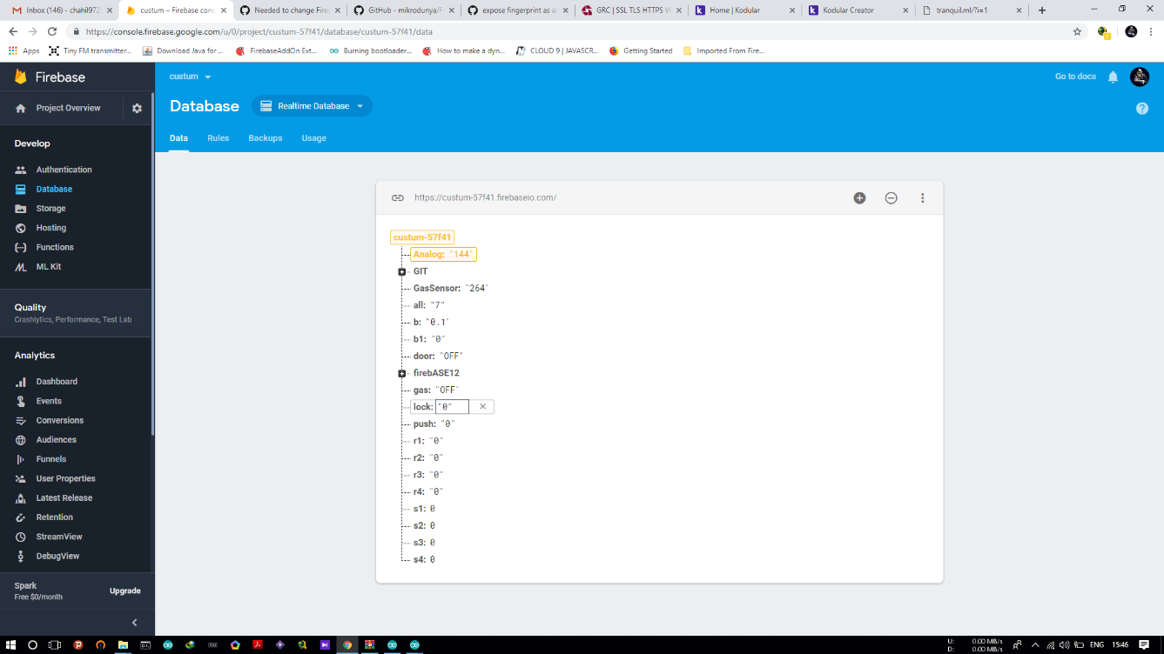

**Fig. 7.2. Server side application screenshot**

**Chapter-8**

**Conclusion & Future**

**Work**

**8.1. Conclusion**

In this span of time, we have learned many new technology and gained wide knowledge. It helped us to manage time, maintain good team spirit and even having the positive on our behavior. To conclude, this project was a great experience for us.

**8.2. Future Work**

There are various types of enhancements that could be made to this system to achieve greater accuracy in sensing and detection. In future, we will try to make the hardware of home automation a little less complicated and a very easy application. We can change the way of automated notifications by using the GSM module to make the system a little more of professional.

**Appendix - A**

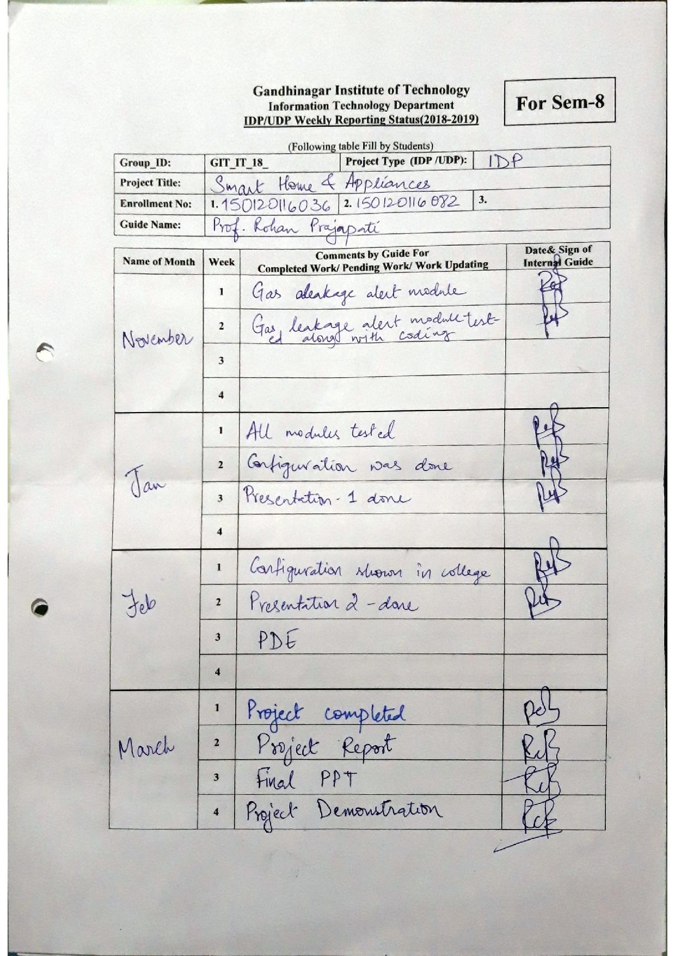

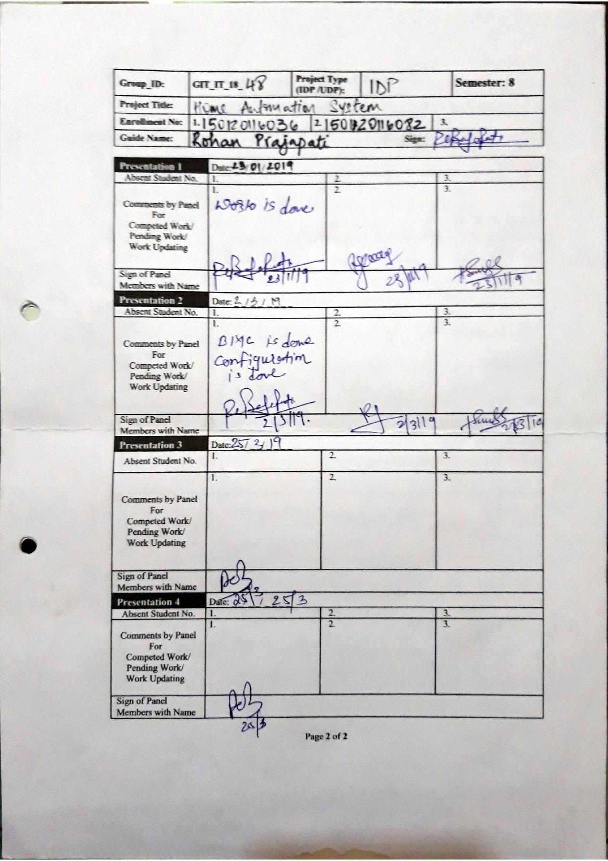

**Appendix: B**

**BMC Canvas**

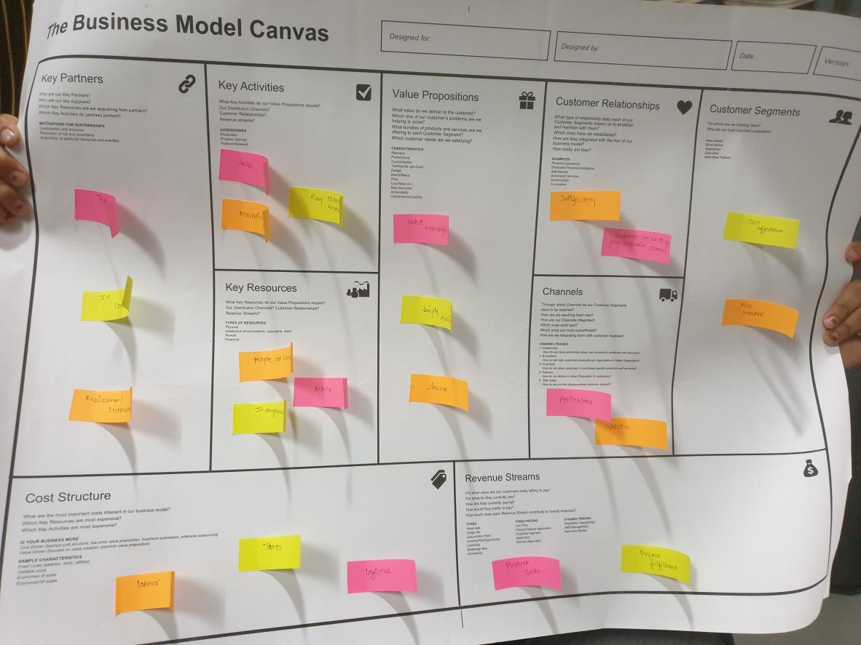

**Customer Segments**

Mass Market

Cost efficient

**Value Proposition**

Latest Technology

**Channels**

Application

Website

**Customer Relationship**

Satisfactory

Security

**Revenue Streams**

Product Sales

Project Fulfillment

**Key Activities**

Interpol-able

Energy Saving

**Key Partnership**

Tech Supplies

Businessmen

IT Companies

**Key Resources**

Homes

Offices

**Cost Structure**

Marketing

Logistics

**References**

1. <http://researchpub.org/journal/jac/number/vol5-no2/vol5-no2-3.pdf>
2. [https://www.softwaretestinghelp.com/internet-of-things-iot](https://www.softwaretestinghelp.com/internet-of-things-iot-testing/)
3. <https://www.researchgate.net/publication/224696459_The_Smart_Home_Concept_our_immediate_future>